Date | Classification  Debug /  Creation /  Testing / | Evidence | Description of work done | Description of problem solved if applicable
29/07 | Creation | 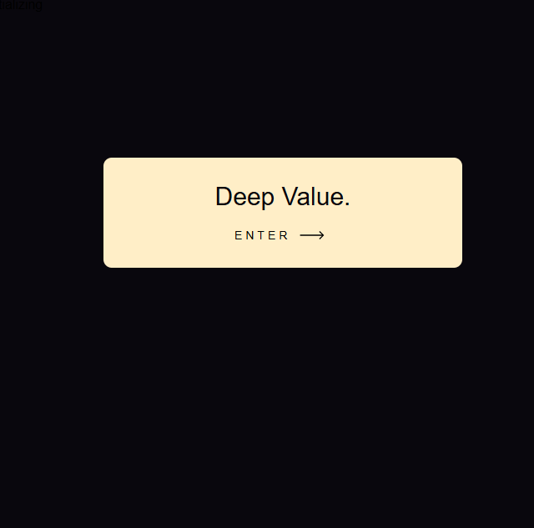 | Coding the basic version of the home page of my Investment Journal  I added a button which I found on this website Button by alexmaracinaru made with CSS | Uiverse.io
29/07 | Debug | 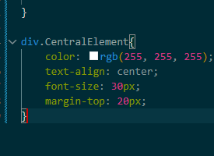  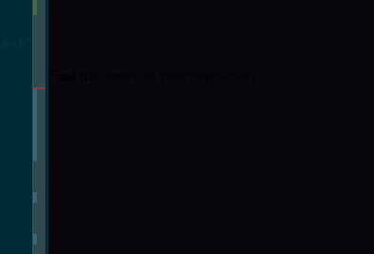 | Debugging why the text isn’t showing up properly | I needed to remove the space between Central and Element to ensure the syntax was correct so that my div could detect the right CSS and apply it
2/08/26 | Stylistic additions |  | I added a new button that looks like a neon sign and gave the websites landing page a more distinctive colour scheme, now it feels unique.
3/08/26 | Stylistic additions |   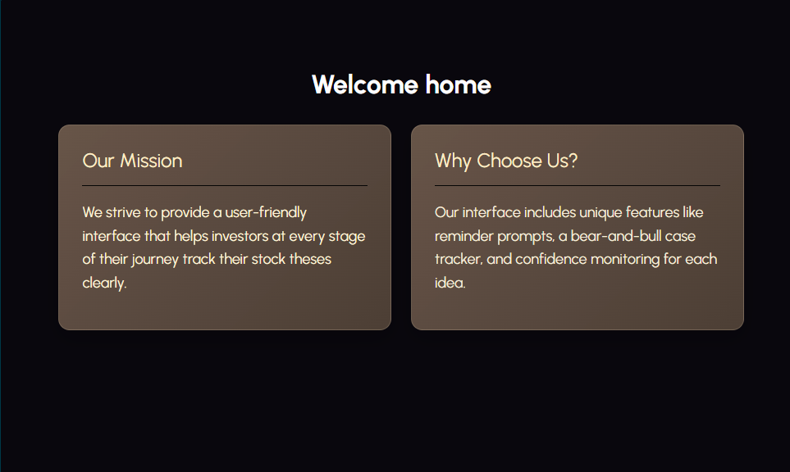 | I updated the colour schemes, I think this is a good change. I think the landing page especially looks really refined now.
3/08/26 | Stylistic additions | 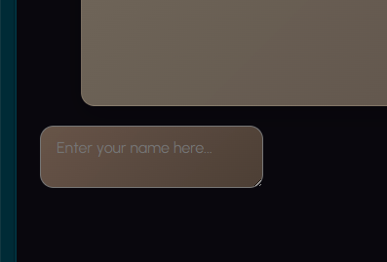 | I need a way for users to enter their name so that the system has a more personal touch. I will do this through a typing box and a send / enter button. | I will do this through some basic textarea code tutorial found at this website: HTML Text Box Code  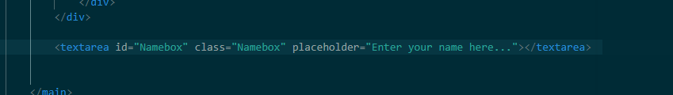
3/08/26 | Debug | 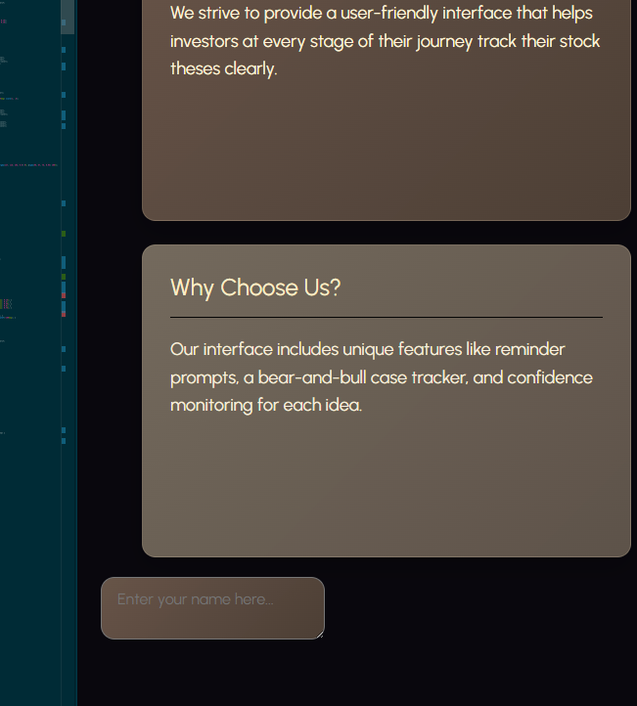 | The Text box is not aligning to the centre of the page when I try to use align-items: centre; | I needed to add these four lines of code under home-shell rather than Namebox, because the name box is also under home-shell. I made some changes to the layout so that the main content is now centered on the page, rather than being stuck too high up or following the usual flow of the document. This gives it a neater look. I also tidied up the container to make it look more streamlined and kept the spacing consistent, which makes the page feel more polished. The headings and content blocks look more organized and the whole page is easier to read and more balanced.  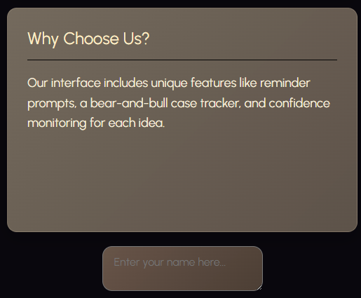  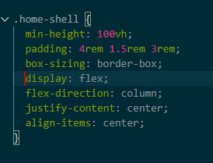
4/08/26 | Creation | 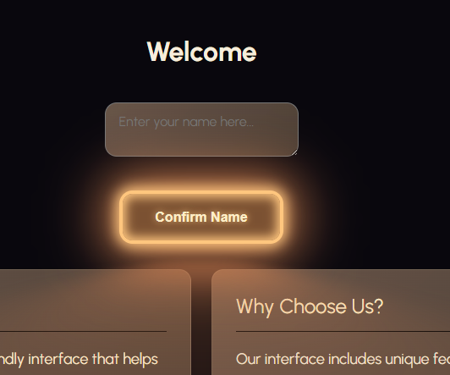  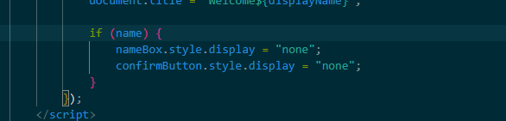 | I added a feature to let the user enter their name to give the system a more personal touch. This allows the user to type their name into the box below the welcome sign, press confirm name, and then it personalises the welcome message like welcome (Name). After the system listens for the button click it reads the entered name and puts it into the welcome message framework. The button and textbox hide after a name has been entered to make the interface appear more cleanly.
6/08/26 | Creation |  | I added a basic stock ticker list to display the stocks and their percentage changes and values
10/08/26 | Stylistic additions | 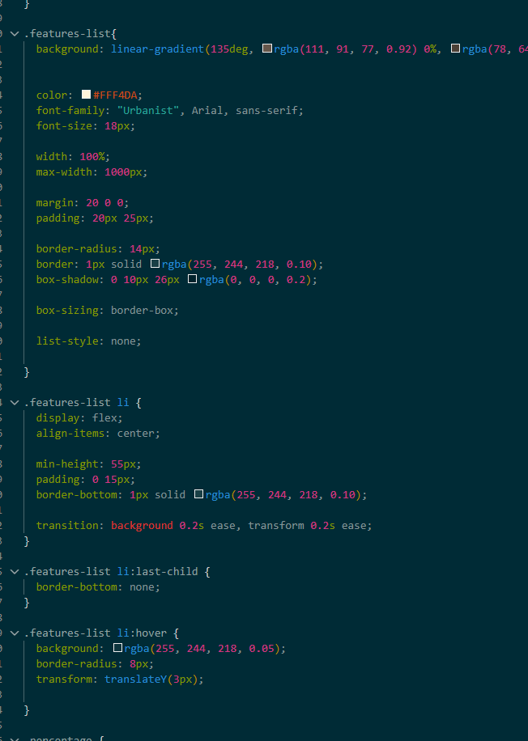  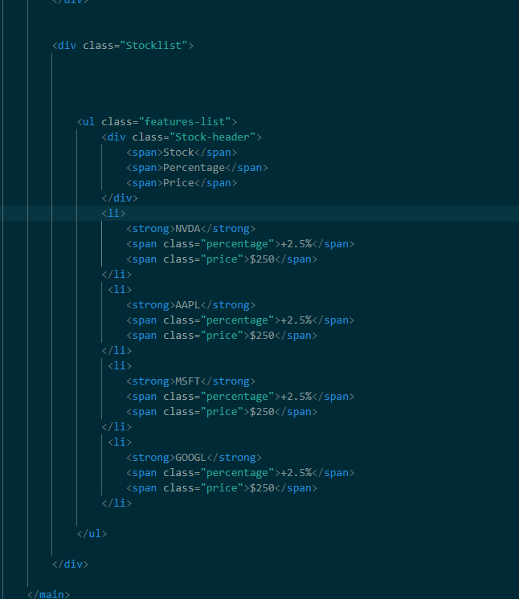  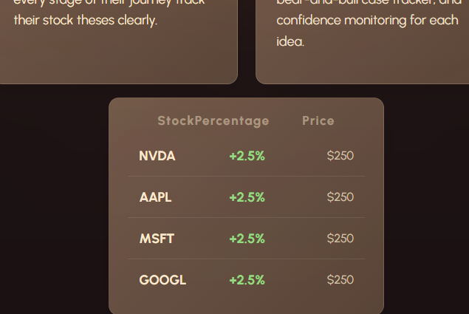 | I restyled the Stock ticker list so that it looks more visually appealing and fills up more of the screen  What I changed / did in terms of code:  CSS:  List-style: none has been used to remove the bullet points that <ul> usually puts in  Display:flex arranges the items horizontally, within the row. And they are also centered  Margin-left: auto pushes all the percentage price and name to the left so that there aren’t really large gaps in between, and it looks uniform  Specified with on price gives each price the same amount of horizontal space  Padding on the list of 20px makes the list compact and easy to read  Border-bottom creates a horizontal line underneath each stock  .features-list li:last-child { border-bottom: none; }  Removes the horizontal line under the last card so it doesn’t look bad  .percentage.negative {  color: #FF8A8A;  }  Negative percentage colour because it could be confusing having green negatives | <div class="ExplanationRow">  <div class="Explanation">  <h2>Our Mission</h2>  <hr>  <p>We strive to provide a user-friendly interface that helps investors at every stage of their journey track their stock theses clearly.</p>  </div>  <div class="Explanation2">  <h2>Why Choose Us?</h2>  <hr>  <p>Our interface includes unique features like reminder prompts, a bear-and-bull case tracker, and confidence monitoring for each idea.</p>  </div>  </div>  </div>
11/08/2026 | Ideation | 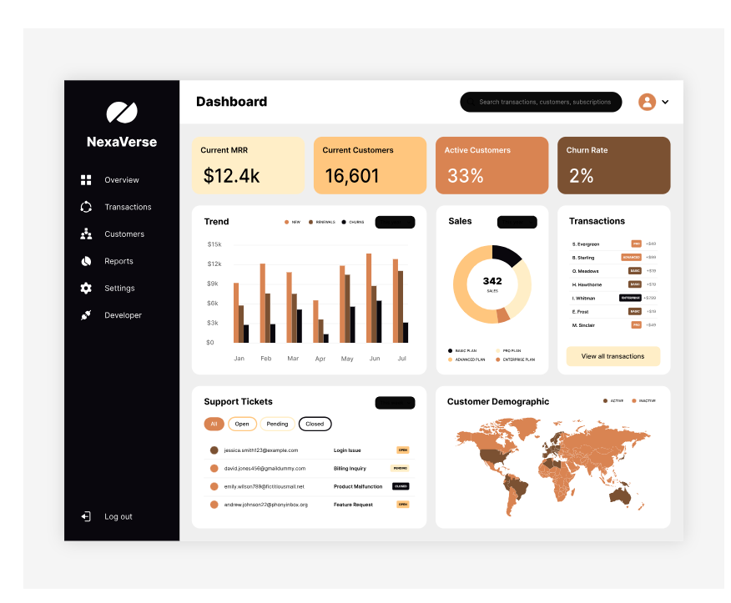 | I think I want to change my direction for my home page, it should look more like a dashboard than a welcome page that tells the user what the interface does, that can be for another place.
11/08/2026 | Creation |   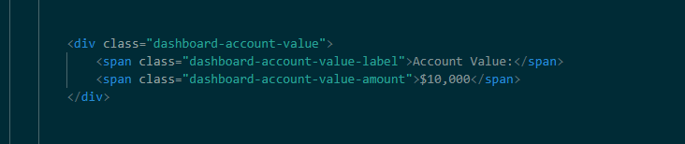 | Basic account value box for the dashboard to ensure the user knows how much money they are dealing with.  I did this with a basic div inside my dashboard home shell main. I reused the CSS from the explanation boxes because its similar to what I wanted here.  font-family: "Urbanist", sans-serif;  color: #F7EEDC;  text-align: left;  font-size: clamp(2rem, 4vw, 3.2rem);  letter-spacing: 0.16em;  margin: 0;  font-weight: 700;  line-height: 1;
11/08/2026 | Debug |  | The real holding value is not displaying on a separate line to the actual dollar amount, which I think is necessary for a clear user experience. | 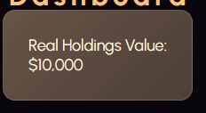  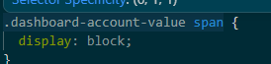  I fixed it by adding  .dashboard-account-value span {  display: block;  }  With display:block; each span element within the .dashboard-account-value div takes up its own line rather than the default inline. This means that the value and the title which are in different spans but are under the same div separate into two lines.
11/08/2026 | Debug | 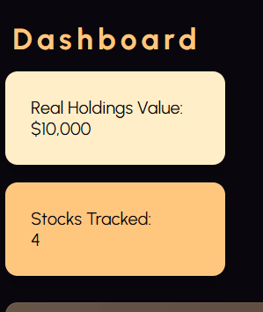  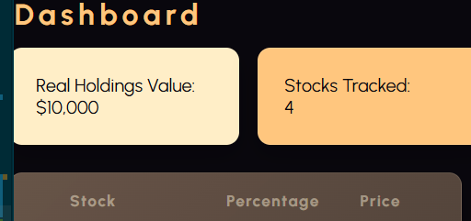 | Second widget with very similar code to the Real Holdings value added but its not displaying side by side, like my reference picture  The code I used to fix this:  .dashboard-widgets {  display: flex;  flex-direction: row;  flex-wrap: nowrap;  }  .dashboard-account-value,  .dashboard-stocks-tracked {  flex: 0 0 auto;  }  It turns dashboard-widgets into a flex container, and then orders the flexbox to arrange the items horizontally, which means they sit side by side on a full VW screen.
11/08/2026 | Debug | 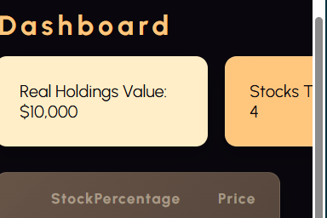 | When I make the VW smaller instead of flexing around to another row the widgets are forced off the screen. This is bad because on mobile phone screens users will not be able to see the other widgets.  The error is occurring because of flex-wrap:nowrap; which physically stops the widgets from wrapping around if the vw isn’t wide enough onto the next row.  Removal of this doesn’t fix the issue yet. But I can fix it using media queries. If the VW becomes less than two boxes are wide I can make it set flex-wrap to wrap; which will force the other box onto the second row. I cannot just use universal flex-wrap: wrap; as then the boxes don’t sit side by side. | 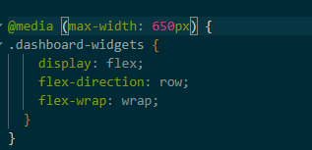  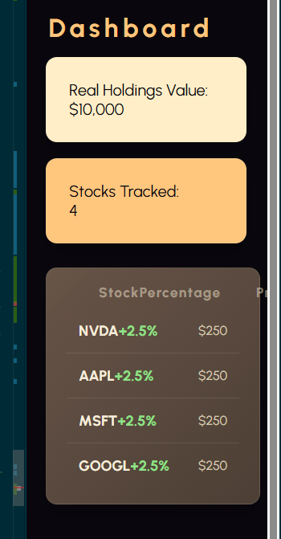
11/08/2026 | Refining and simplifying code | 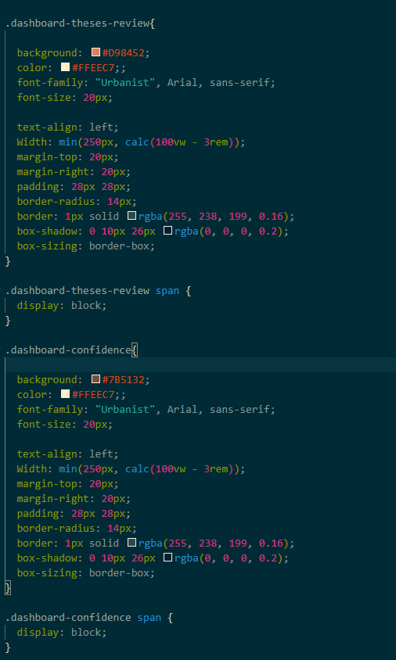 | Currently each of the four widgets has its own styling blocks, for every property. This takes up a large amount of space on my CSS and could easily be simplified, as the only thing different across them is background colour and regular colour. | 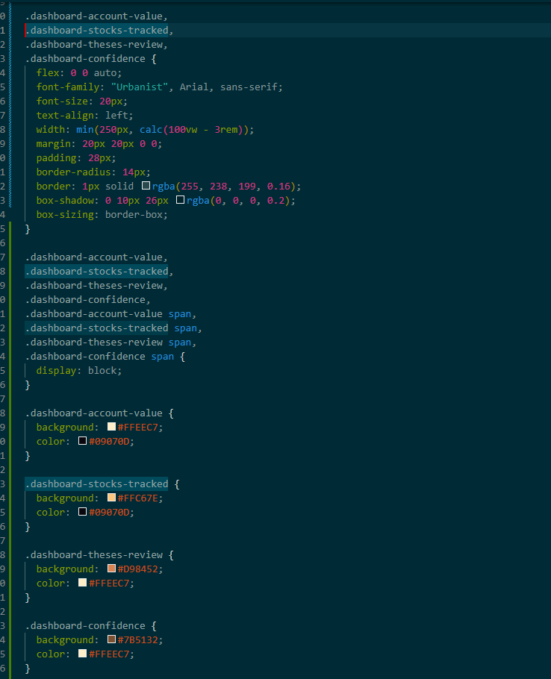
11/08/26 | Creation + debug | 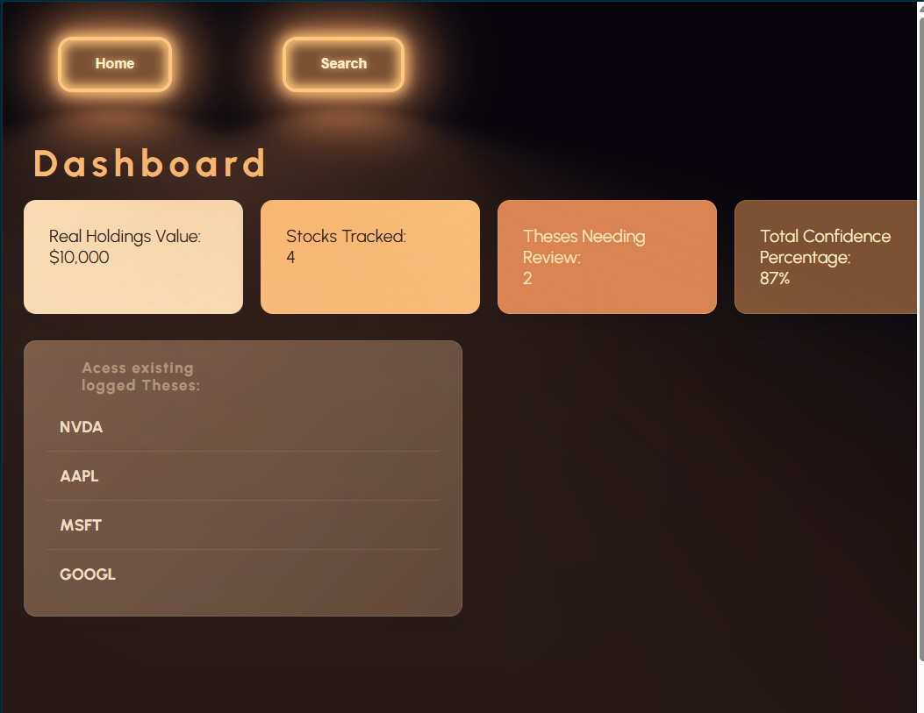 | Added a basic navigation bar.  I really like the border and lighting effect from these buttons but I think it looks weird to have two of them. I’m going to apply the effect to the navigation panel and style the buttons regularly. | 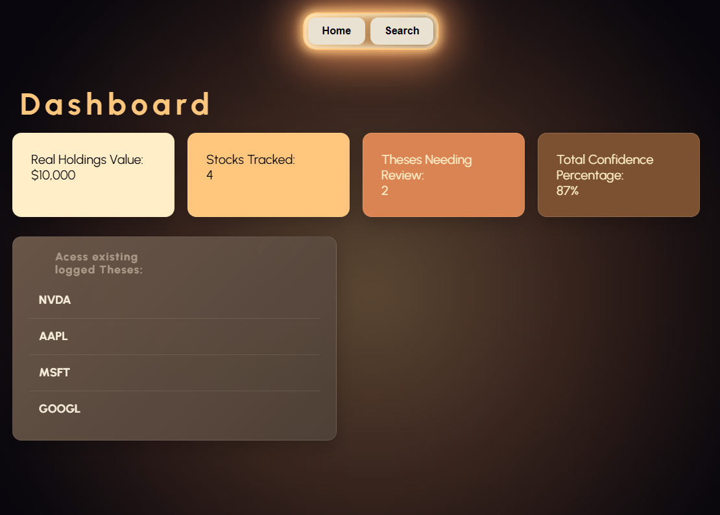  I changed the styling so that the individual buttons of the nav bar didn’t glow, the navigation panel around them did.  Debug:  - The special imported button style was applied globally to all <button> buttons.  - I added ‘regular-button’ classes to the two buttons I wanted in the navigation bar.  - I ensured that I styles these to have no boarder, box shadow or text shadow and after glow, to make them as plain as possible.  - I tigheted the navigation shell sizing to ensure the border lines up with the buttons correctly
11/08/26 | Creation + ideation | 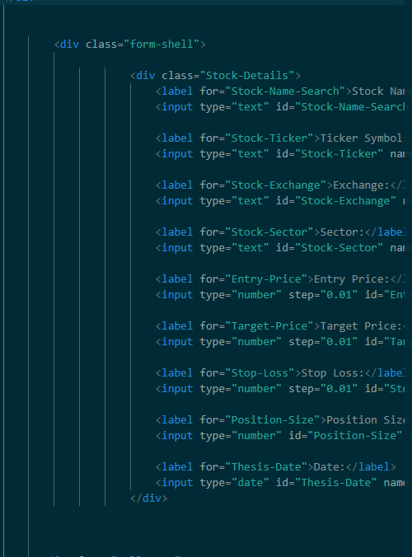  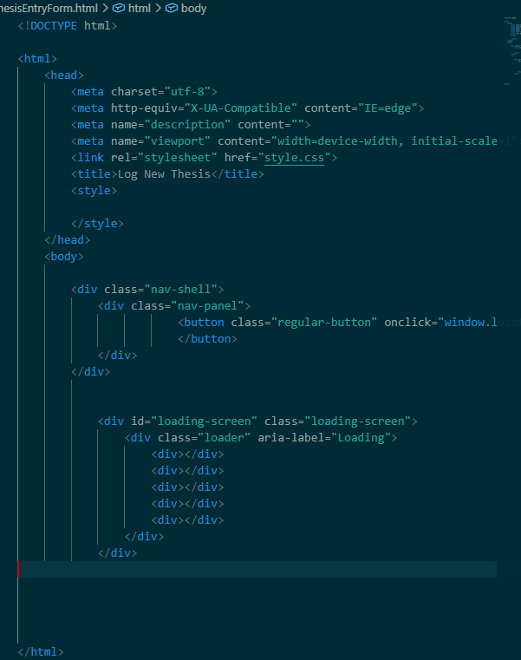 | I need a way for users to enter their thesis for new stocks. I think the best way to do this is to like one of the buttons at the top to a new document where the user can select the stock and enter their thesis.  I will use a new HTML doc for clarity.  I used the same basic structure as my JournalHome.html with the same loading screen and button style for the navigation.  I think I should use a json to log user thesis by stock then I can use it to populate the journalhome.html even though its recorded on the newthesisform html  I essentially just added a bunch of input boxes, which I am yet to style, using <input>  I used a slider for entering the users confidence level. There is some simple javascript that makes this work and makes it update the lettering beside it. The function reads the current value of the slider using confidenceSlider.value, and then creates a string from 0 – 100. This is then written into the confidence value span, which is like a template that adds the percentage on after it.  confidenceSlider.addEventListener('input', updateConfidenceValue);  updateConfidenceValue();  makes the display update live and updates the span every time the page loads. | 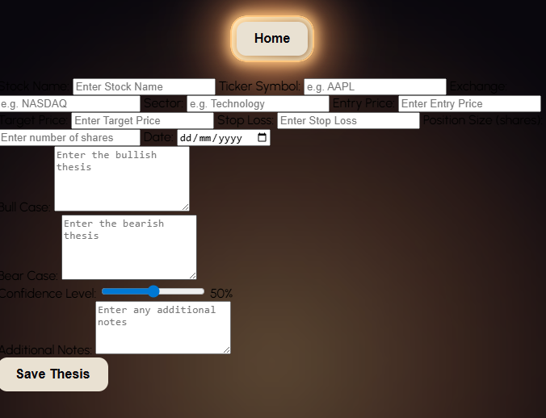
13/08/2026 | Debug | 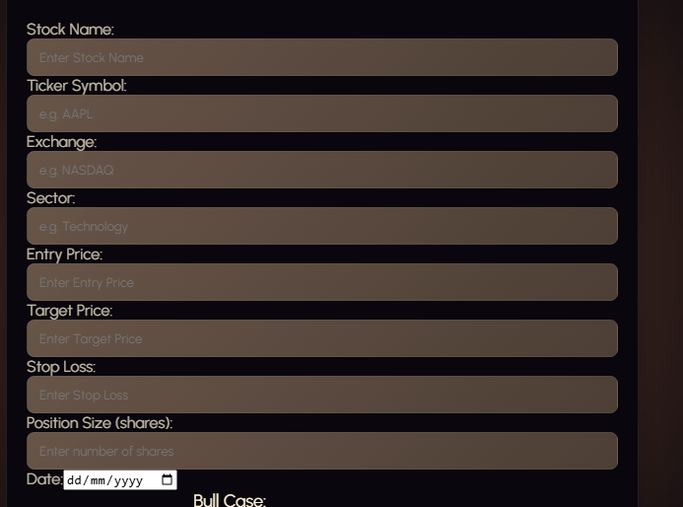 | Currently there’s no space between the lines in my new thesis form. This makes it visually challenging to read, and is not very visually appealing. How I solved this issue: | When trying to use stock-details in my css and adding a margin-top of 20px, it applied it to the whole div, so every different category inside the Stock-Details div was just shifted down 20px. I used <label> when coding the html for each category. To add Css for this I needed to address all of the labels within the Stock Details div, so I used the header .Stock-Details label {}, and it worked nicely. I added a margin-top of 20px; for some visual separation and it looks much better now.  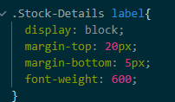  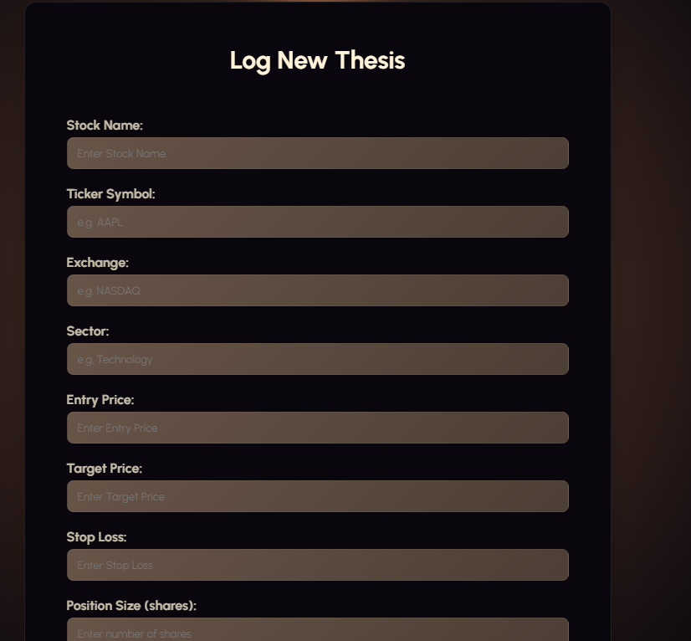
13/08/2026 | Stylistic aditions | 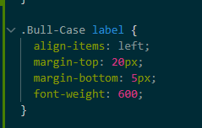 | The other parts of my form lie outside the Stock-details div. so for Bull-Case, Bear-case, etc hence do not get the spacing applied to them. I will create separate CSS blocks for them with the same code | 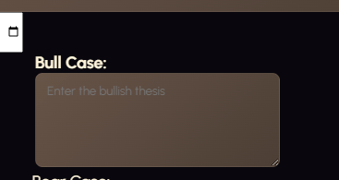
13/08/2026 | Debug | 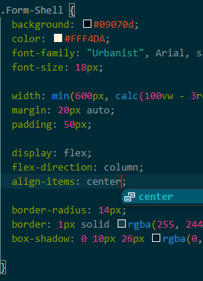 | Its not letting me align the bull-case left using its label CSS, which it should be. | 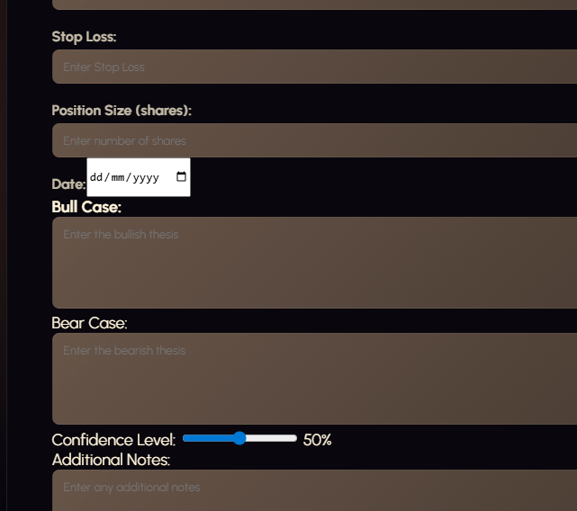  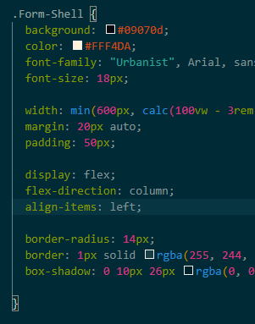  The is is that its being set ‘items-align’ center within the form-shell css above it. So to fix this problem I need to change that to left.
13/08/2026 | Debug | 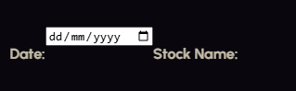  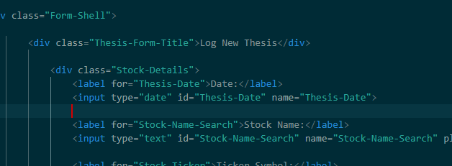 | Due to its special function with the date entry box the  .Stock-Details label {  display: block;  margin-top: 20px;  margin-bottom: 5px;  font-weight: 600;  }  Isn’t applying to it well, and it just looks bad, there is a way to style it using  #Thesis-Date { margin-top: 20px; }, but the actual date box looks off, and has it placed randomly next to the text. Its also making the label for the stock-name section stick to it on the wrong line.  To solve this issue, I’m going to create the date section its own div to ensure I can style it directly, and make it look visually appealing. | Giving the date section its own div creates a container around the date label and input, it gives me a specific target for CSS allowing me to make custom changes just for that section, which include the label and input – so I can change it from the white colour that doesn’t match my colour scheme.  This also lets me control the layout of the date section independently.  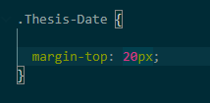  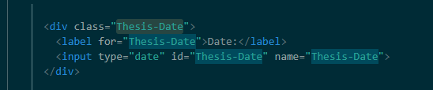
13/08/2026 | Debug |  | I need to stop the stock name title from sticking to the same line as the date. I think this is happening because the date section is built differently to the other parts of my stock-details div, hence it may not be taking up the full width of the form and allowing the Stock Name title to flex up onto the same line as it.  I will try to fix this by setting the width of the thesis-date div specifically to 100%  Problem solved. | 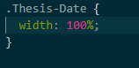  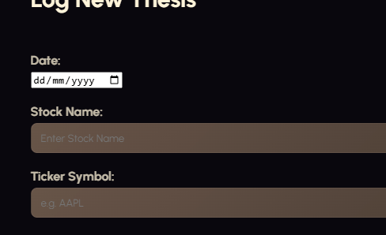
13/08/2026 | Stylistic additions | 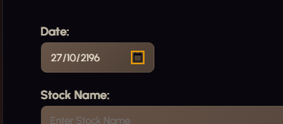  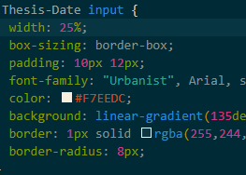 | Styled the date section like all the other boxes, I need to test the inputs that this date box lets my use because it shouldn’t be letting me enter dates well into the future.
13/08/2026 | Stylistic additions | 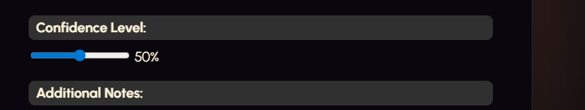 | I wated to give the slider some styling because I thought it looked bare without it.  .Confidence-Level input[type="range"] {  width: 70%;  margin-top: 20px;  margin-bottom: 10px;  }  Confidence-level finds an element with the class-confidence level. Then input[type=”range”] means find an input within the confidence level whose input type is range, so it targets my slider. Then it applies the 70% width property to stretch it across 70% of the stock-details div. and the usual margin properties.  #Confidence-Level::-webkit-slider-runnable-track {  height: 6px;  background: rgb(97, 97, 97);  border-radius: 5px;  }  Similar to the code from before, but the :: double colon is for a pseudo-element, essentially it targets the track belonging to the range with the class confidence-level my properties make it gray and change its width.  #Confidence-Level::-webkit-slider-thumb {  appearance: none;  width: 18px;  height: 18px;  background: #a79797;  border-radius: 50%;  cursor: pointer;  margin-top: -6px;  }  Is essentially the same thing but for the little circle, the margin top is used to align it on the track, I gave it a size, but the background colour doesn’t work for some reason. That’s ok.  Overall my form looks a lot better. | 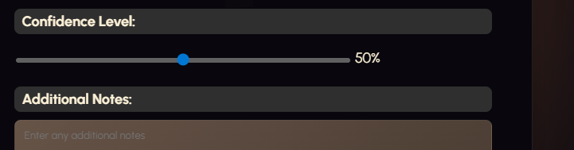  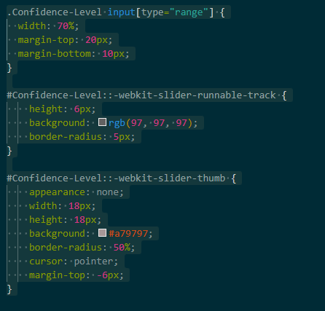  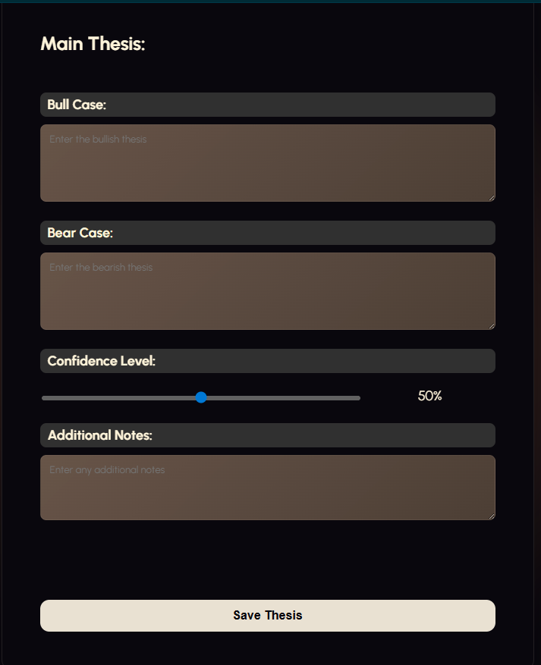
13/08/2026 | Relevant implications addition – Privacy | 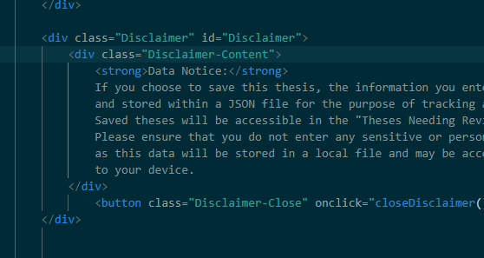  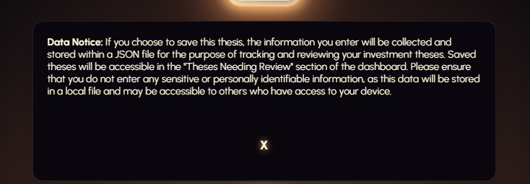 | I need to add a disclaimer at the top of my new thesis form telling users that if they save their thesis it’s going to record their data.  My disclaimer is pretty basic, its just a div with some text and a button which I needed to manually remove all the styling from because my <button> is set to glow like a neon light.  Because I’ve talked about how I code divs before the only really unique thing is the small javascript function that makes the message disappear  function closeDisclaimer() {  document.getElementById("Disclaimer").style.display = "none";  }  closeDisclaimer is the name of the function linked to my button, and when it is pressed the HTML doc is searched for a div with class Disclaimer – being my disclaimer message, and it sets all of its CSS display properties to none so that it cannot be seen
14/08/2026 | Relevant implications addition – Privacy | 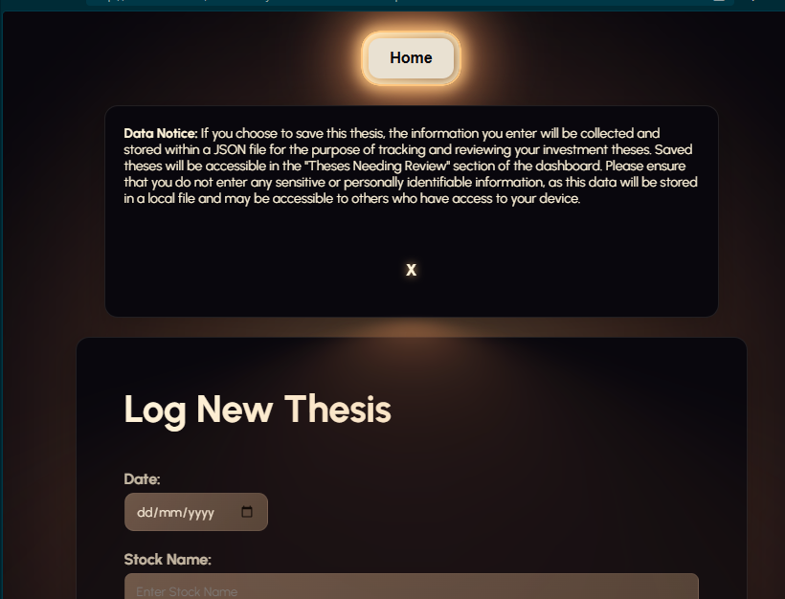 | Currently the disclaimer message just pops up at the top of the screen below the nav bar, and pushes the rest of the content down. I not only think this looks bad, but it means the user can still access the form to log a new thesis without confirming their opinion on the data usage. This is bad because it means if the user chooses to ignore the disclaimer like many do, they won’t be informed about the saving of their data.  To solve this I will make the disclaimer popup on the screen in the centre, when the page is opened. I will also blur the background around it to put all of the users focus on it.
14/08/2026 | Debug | 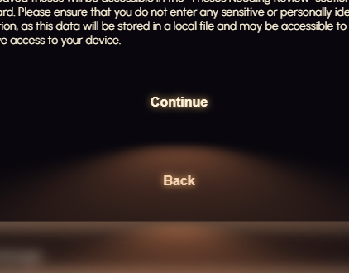 | Because the special imported button from UI verse applies styling to the basic buttons, I have to manually remove the styles where I want to. I want to get rid of this blurred triangular glow effect from the buttons. To solve this problem I searched for the styling on the regular buttons that could be producing this  Button::after pseudo-element has filter: blur(2em) which is potentially creating the flow effect. Essentially this blur effect was also applying to my disclaimer-close buttons.  To solve this I added a disclaimer-close::after pseudo element as well and set it so that nothing from the after pseudoelement displayed, so that the blur would stop being there.  .Disclaimer-Close::after {  content: none;  display: none;  }  Content-none; removes the content of the pseudo element and display: none; hides it entirely so that it does not render  Button::after pseudo element created the blur effect with  button::after {  pointer-events: none;  content: "";  position: absolute;  top: 120%;  left: 0;  height: 100%;  width: 100%;  background-color: var(--glow-spread-color);  filter: blur(2em);  opacity: .7;  transform: perspective(1.5em) rotateX(35deg) scale(1, .6);  }  Background color gives the browny beig colour  Filter: blur gives it that blurred gradient effect  Transform skews it into a triangle shape positioned below the triangle, so  Disclaimer-Close::after {  content: none;  display: none;  }  Stops all these properties applying to the disclaimer close button. | 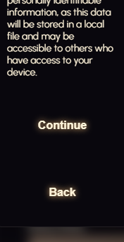
17/08/26 | Debug | 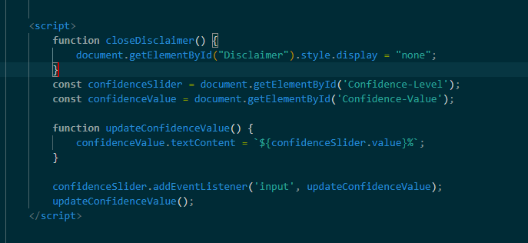  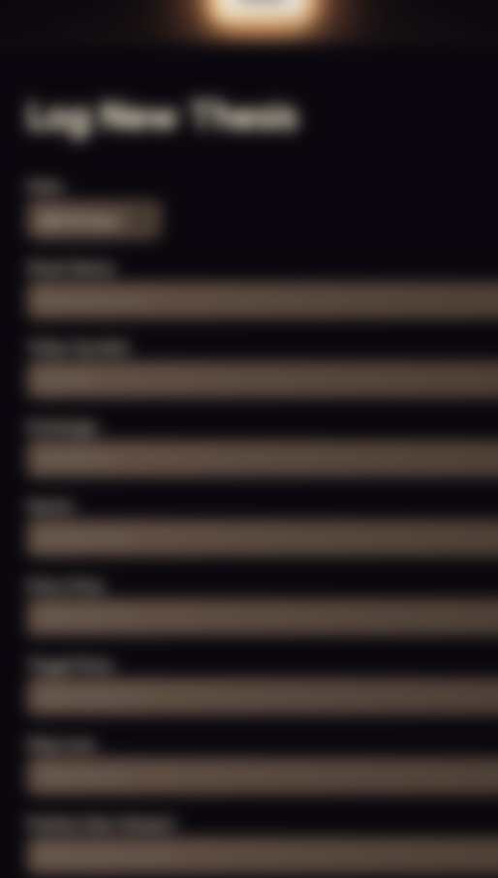
17/08/26 | Adding JSON functionality from the form

